


MULTI-ELECTRODE PROBE 10 Electrode Version (FOGRod Brand) with Liquid Indicator Transmitter (LIT) Manual v2.16

EXCLUSIVE DISTRIBUTOR – EMEA

Water Automation Technology
Suite 1, 21 Highfield Drive
Kingsbridge
Devon TQ7 1JR

Sales and technical support
Mobile: +44(0)7384966112
Website: www.waterauto.co.uk
Email: contact@waterauto.co.uk
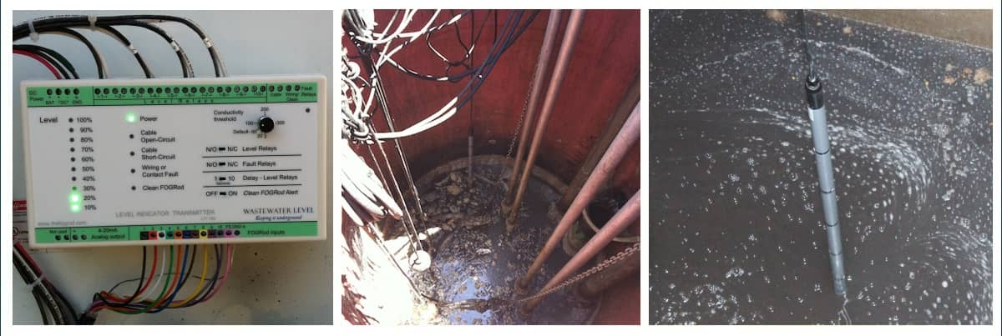

FOGRod (with a TEN year warranty) is a Multi-electrode conductive probe for ultra-reliable water and wastewater level detection. A simple, cost effective fit and forget alternative to ultrasonics, radar, ball floats, hawker probes etc.

Excellent reliability in many applications including:
- Deep wet wells
- Cluttered wet wells
- Wet wells that completely flood so non-contact (radar etc) unsuitable
- Thick sludge
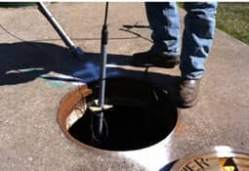
- Foaming
- Heavy FOG contamination (fat, oils and grease)
- Water and sewage treatment inlet works
- Boreholes
- Storm tanks
- Retrofit problematic sites

Contact us to discuss your application.
- FREE site surveys
- FREE 30 day trials
- FREE product training on customer premises

MANUFACTURER

Wastewater Level LLC
780 Conrad Drive, Kalispell, MT 59901

Table of Contents

Version History 3
Introduction 4
How the FOGRod and LIT work 4

Detecting Grease & Ragging and Preventing Short Cycling in v1.7 4

Improved Noise Performance of Cable Alarms in v1.8 5
FOGRod installation 6

Recommendations for Setpoints 7
LIT Installation & Simple Commissioning 9

Physical Location 10

Ground and Power Supply Connection 10

Lightning Protection - IMPORTANT 11

FOGRod Connection 12

3 ft FOGRod 12

Wiring Level Relays 13
Basic Commissioning 16

Fault Conditions during Commissioning 17
Cleaning the FOGRod 18
Understanding the LIT & FOGRod Functionality 19

Understanding Operator Panel Alarms and Fault Relays 19

Clean FOGRod Alarm 20

Configuration Settings 21
Analog Output 22

Wiring the Analog Output 22
Hazardous Location Installation 23

Class I Division 2 23

Class I Division 1 25
Troubleshooting 28

No Level Signal 28

Level Signal when Wetwell is Empty 30

Cable Open Circuit 31

Cable Short Circuit 31

Wiring/Contact Fault alarm 32

Clean FOGRod alarm 33
Specification 34

LIT-100 34

FOGRod 36

Version History
Manual

Version |  | Summary of Changes | Pages Affected | Reason for Change
v2.5 | July 28th, 2014 | Cosmetic. Clarification for FOGRod cleaning based on customer feedback | p.8 (on half size letter version) | Minor clarification
v2.6 | Feb 19th, 2015 | Overlay text changed slightly.  More explanation about the faults. | pp 4 & 19 | Text change to LIT overlay
v2.8 | April 20th, 2015 | Added a history of changes.  Explained new s/w features of v1.6. | All, due to slightly new page structure | New s/w version -Clean FOGRod alarm
v2.9 | May 25th, 2015 | Explained new s/w features of v1.7. | All, due to slightly new page structure | New s/w version -Clean FOGRod alarm
v2.10 | Aug 18th, 2015 | Added wiring details for Class I Div 1 for IS barrier from R Stahl | Added new page 24 | New accessory
v2.11 | Oct 29th, 2015 | Updated troubleshooting | Updated p.27-28 | Clarification
v2.13 | Aug 12th, 2016 | Add s/w v1.8. Updated commissioning, 3ft Fogrod & troubleshooting | Commissioning / Troubleshooting | New s/w version.  Clarification.
v2.14 | Oct 31st, 2016 | Added approvals, including Canadian and European | p.31 | Clarification
v2.16 | Jan 19th, 2017 | Updated for new lightning protection and new overlay text | pp 11 & 12 | New wiring requirement

Software

Software Version
v1.5 | June 4th, 2014 | Minor change: Removed attempt to differentiate between bad grease build up and commissioning / cleaning of FOGRod
v1.6 | April 20th, 2015 | - Clean FOGRod alarm prevented from activating within 10 seconds of a power reset - to stop power resets activating the Clean FOGRod alarm  - Clean FOGRod alarm “latches” (instead of reseting when the level drops below the contacts that were affected)
v1.7 | May 25th, 2015 | Adds to the changes in v1.6 with a feature to minimize short-cycling due to grease and rags:  When Clean FOGRod condition is detected, only the first new ‘wet’ contact activates a level relay, then an internal timer starts. At the end of the timer period if those same contacts are still apparently ‘wet’ the LIT activates all those level relays and latches the Clean FOGRod alarm
v1.8 | July 1st, 2016 | Improved noise threshold of Cable alarms

Introduction
Thankyou for getting your hands on a FOGRod and Level Indicator Transmitter (LIT).
Our products are designed to help you free up your time. This means that if you have problems or feedback we want to know.
Product improvement suggestions, pointing out information in our manual that you found confusing, problems that are concerning you - please tell us.
We value feedback on your experience using the FOGRod. In fact, even though modern technology makes it easy for you to show us a photo or video, we would love to show up at your facility and see what’s actually going on.
Speaking to a real person at Wastewater Level is pretty easy. If for some reason everyone is unavailable when you call, we will call you back within a few minutes or, in exceptional circumstances, in a few hours.
You are the customer. We are serious about making your life easier.

How the FOGRod and LIT work
The principle of operation is very simple. Water is conductive. The FOGRod hangs vertically in the well and has 10 equally spaced metal contacts down its length. Each metal contact is internally connected to one core of an 11-core cable and the 11-cores are wired into the Level Indicator Transmitter (LIT).
The LIT applies a very low AC voltage, 5.6v (r.m.s), to each of 10 wires. If the FOGRod metal contact is out of the water (dry) then no current will flow. If the contact is under water (wet) then current flows through the water to ground and back to the LIT.
The FOGRod will get covered in Fats, Oils and Grease (FOG). However, if you hang it in the turbulent part of the well the FOG will be broken up and the FOGRod sees through the FOG.
The sensing circuits inside the LIT detect the current flow. Therefore, it determines which metal contacts are under water.
The front panel of the LIT displays the level and any fault conditions. The 4-20mA analog output (AOUT) transmits the level in 1mA steps. The 10 dry-contact relays activate based on the level measured. The two fault relays activate based on various fault conditions.
The FOGRod & LIT can replace floats, a pressure transducer, a bubbler or an ultrasonic.
In most cases, the replacement can take place without any re-configuration of your PLC, pump controller or simple control panel logic.
The 11th wire from the FOGRod is used to provide a cable continuity test. The LIT tests this continuity and indicates any cable fault on the front panel and via a fault relay.

Detecting Grease & Ragging and Preventing Short Cycling in v1.7
The LIT has patented logic to detect, and deal with, grease and rags. It detects bad grease build up and ragging in two main ways:

Dry below Wet
If the LIT registers a wet FOGRod contact above a dry contact it creates an alarm: Wiring or Contact Fault. This creates a red LED on the LIT and activates a fault relay.
The unit uses the highest level detected as the “real” level. For example, if the contact for the lead pump stops working (due to complete insulation from very bad grease or due to internal problems) and the level rises to the next contact the LIT will turn on all the level relays up to that point - so the lead pump will still start (just a bit higher).
It’s very simple backup logic that means your pumps will always start. It’s like having “backup floats” above the “lead float”, with some inbuilt redundancy logic.

Multiple contacts activating together
If the LIT sees multiple FOGRod contacts change from dry to wet at the same time it knows that this is not correct.
The physical reason behind the condition is either rags or, more commonly, bad grease buildup that holds water inside the grease and shorts out multiple contacts.
This can cause short cycling of pumps. This can be the “achilles heel” of conductivity rods. In the extreme case bad grease or rags will short out the stop point to the lead start. So, in this extreme case, when the water hits the bottom of the rod it short circuits to the lead start. And so the lead pump kicks on. Within a few seconds the level has dropped below the bottom of the rod and the pump stops. A few seconds later and the level has increased back to the bottom of the rod and the lead pump starts again.
This is an extreme case. For this extreme case to take place by grease buildup usually takes many months - and in most installations never happens. It can take place by rags much quicker - although the FOGRod is designed to minimise ragging problems due to the 120 degree offset between adjacent contacts.
In v1.5 (and earlier) the software detected the fault condition and activated the Clean FOGRod alarm and the corresponding fault relay. This alerts operations staff.
In v1.6 the fault latches and the affected level LEDs flash - the fault light, fault relay and flashing LEDs do not deactivate or clear until the Clean FOGRod DIP switch is moved to OFF (or power resets). This software version was a step towards v1.7. (In v1.5 the fault did not latch - when the level dropped below the affected level the fault cleared).
In v1.7 there is a significant and important change. When multiple contacts go wet together (within 5 seconds) a 3 minute timer starts and the Clean FOGRod LED starts flashing. Only the first new level relay turns on. At the end of the timer period if any of the other contacts that went wet are still wet the Clean FOGRod LED goes on (it stops flashing) and the fault relay latches on. The new level is the highest wet contact - so all of the level relays up to the highest wet contact are activated.
This means that ragging and grease problems, even in the extreme, will limit the starts in a two pump station to 10 starts per pump per hour.

See the section Understanding the LIT & FOGRod Functionality for other details on the functionality.

Improved Noise Performance of Cable Alarms in v1.8
In a handful of cases prior to v1.8, the Cable O/C alarm would trigger, often intermittently, even though the FOGRod cable was fine. This was due to noise from the panel, e.g. from being located next to a large transformer, or from noisy soft-starters. v1.8 makes a major change to the internal thresholds to stop any triggering of false alarms. (Note that the Cable O/C alarm doesn’t affect any other operations of the LIT).

FOGRod installation

The FOGRod should be installed in the turbulent part of the wetwell. It is a very tough product.
In the turbulent part of the well the fats, oils and grease (FOG) are broken up. Even with substantial buildup of this broken up FOG the FOGRod can see through it. But in the quiet part of the well the FOG is very “thick” and with substantial buildup on the FOGRod it may have difficulty.
We do not recommend installing the FOGRod in a stilling tube, as it becomes a grease and rags trap. In certain applications it can be a good solution, but this is the exception. We will be happy to discuss your application with you.

Hang the FOGRod near the inflow.

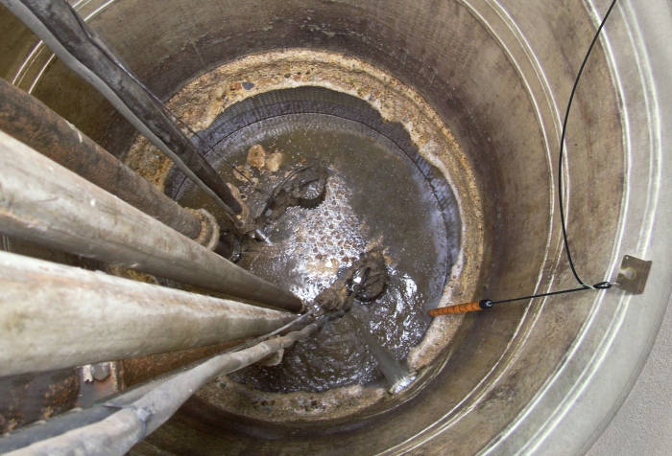
Figure 1

The FOGRod has 10 contacts down its length, any of which can be used for pump start, stop and level alarms.
The contacts are 6 inches apart on the 5 ft FOGRod and 9 inches apart on the 7.5ft FOGRod.
The 10 contacts correspond to 10 relay outputs and also to 1mA steps in the analog output of the LIT.
There is a 3ft version of the FOGRod for special applications, it has 6 contacts down its length, each 6 inches apart.

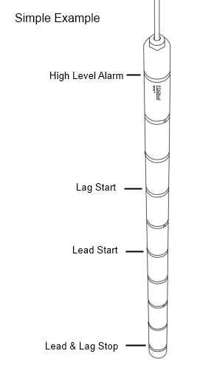
The location of each metal contact is seen by the bands. Each band contains one metal contact (not visible in this graphic). As an example, in the simplest case you could choose: Contact 1 for Off, 5 for Lead Start, 7 for Lag Start and 10 for High Level Alarm:
Figure 2
In this example, level relay 1 on the LIT would correspond to Off, relay 5 to Lead Start, relay 7 to Lag Start, and relay 10 to High Level Alarm.

Recommendations for Setpoints
- Use Contact 1 as Off, and don’t use Contact 1 as Low Level Alarm. Reason: when the level drops below the bottom of the FOGRod it creates an air gap that ensures a stop. Fresh air can’t conduct electric current. But if you use, say, contact 2 as Off and have lots of grease or rags on the FOGRod, the level could be at contact 1 and still be creating a short to contact 2 - that is, not have turned the pumps off. So it’s more reliable to use Contact 1 as Off.
  - If you must have a low level alarm, use an independent low level float - wire it in series with LIT Relay 1, so either the Relay 1 or the low level float will turn off the pumps
- (If possible) Skip at least one contact between Off and Lead Start. Example, 1 is Off and 3 is Lead Start. This allows the Clean FOGRod alarm and delays to work to prevent any short cycling with rags or grease.
- (If possible) Leave a gap between Lead Start and Lag Start. In the example above, say you have a bad grease buildup on contact 5 and it stops registering level. The lead pump won’t start at contact 5. But when the level gets to contact 6 the LIT will register level and it turns on all the level relays up to relay 6 - so the lead pump will start. If Lag Start is on contact 7 (in this example), you avoid the lead and lag pumps coming on together.
The FOGRod comes with a mounting bracket, which includes a cleaning pad:
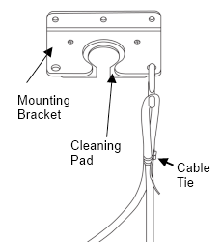
Figure 3

The cleaning pad allows the FOGRod to pulled up through the pad, cleaning off any fats, oils and grease (FOG).
The cable to FOGRod connection will take well over 100 lbs of strain so there is no problem using the cable to pull the FOGRod through the cleaning pad.


The FOGRod must be installed in the turbulent part of the well, but not directly under the inflow.
Leave enough slack in the cable so the FOGRod can be pulled all the way up through the cleaning pad.

- Identify the best place to hang the FOGRod - close to the inflow but not directly underneath the inflow. This should NOT be where the floats were previously hanging. Avoid placing the FOGRod where it will rest against ladders and pump chains.
- Drill holes and screw the mounting bracket in place at the top of the well.
- Hang the FOGRod from its cable, with the bottom contact corresponding to pump stop.
- Tie off the FOGRod cable with a cable tie, hang from the S-hook and sit the S-hook in the mounting bracket.
- Feed the rest of the FOGRod cable through the cable conduit into the control panel.
- Ensure that you keep enough slack in the cable in the well so that you can later pull up the FOGRod by its cable through the cleaning pad.
- The cable can be cut - it is custom cable, but just cable (e.g. no vent tube). You can wire the cable through a junction box - just cut, wire into one side of the junction box, and wire the remaining portion of the cable from the junction box to the control panel.
    - Also, if you need to extend the cable from a junction box and don’t have spare FOGRod cable, you can use regular cable, for example, buy a 12-core shielded instrumentation cable and use 11 of the cores.

LIT Installation & Simple Commissioning

The Level Indicator Transmitter (LIT) works with the FOGRod to provide:
- level and fault signals to your control system (e.g. PLC/RTU or direct into pump starters and fault lights)
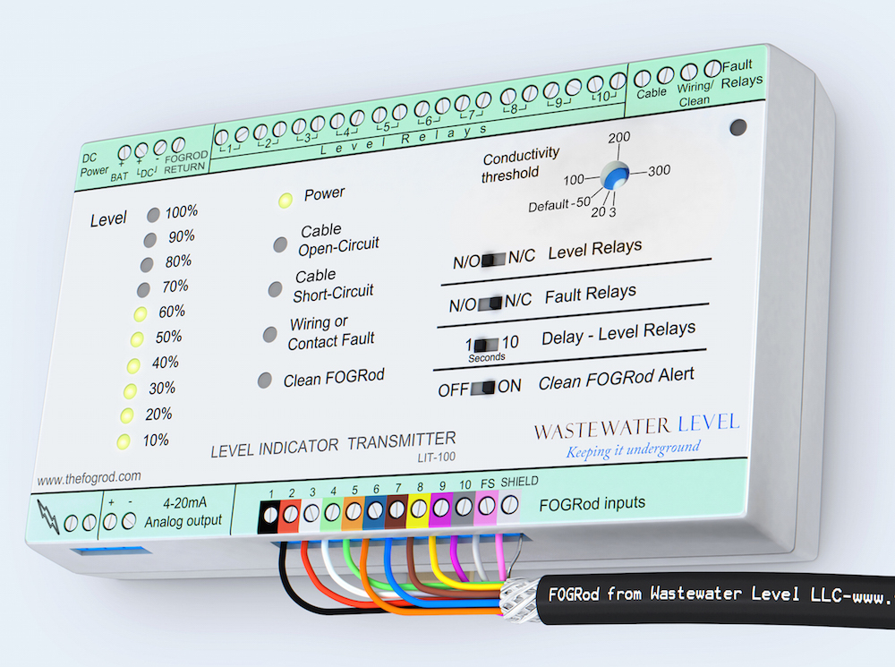
- operator indication
Figure 4

This section identifies the minimum requirements to get your FOGRod & LIT working together.
The LIT has many additional functions and these are explained in the later section Understanding the LIT & FOGRod Functionality.
If the equipment is used in a manner not specified by the manufacturer, the protection provided by the equipment may be impaired.
WARNING - EXPLOSION HAZARD - Substitution of any components may impair suitability for Class I, Division 2

Physical Location
Find some space in your panel for the LIT and clip onto the DIN rail, remembering that you have to connect the FOGRod cable.

Ground and Power Supply Connection
Connect the control panel ground to the FOGROD RETURN terminal in the DC power section (top left) - note: this terminal used to be labeled GND. This is essential as the LIT and FOGRod work by making a low voltage electrical circuit through the wastewater. The ground connection provides the current return.
If the control panel ground is NOT connected to FOGROD RETURN then the system will NOT work.
Do NOT wire the current return from the relays into this terminal on the LIT. You will blow up the LIT.
If for some reason the well is not grounded (e.g. you are using a plastic tank with no ground connections), then you must put a ground rod into the tank and connect this back to the FOGROD RETURN terminal.

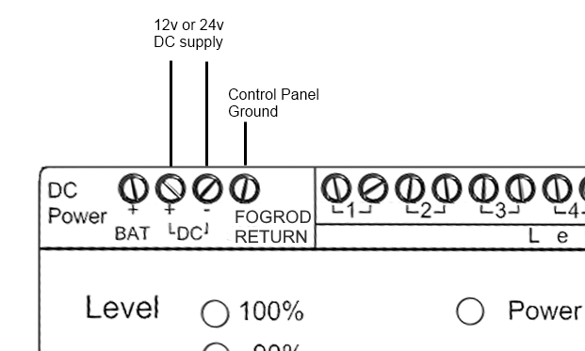
Figure 5

Connect the DC power supply to DC+ and DC-. The LIT should be supplied by DC voltage between 10 - 30v and will consume a maximum of 4W.
Some panels already have a 12v or 24v d.c. supply for their PLC or RTU. You can purchase a dc power supply from Wastewater Level - or locally from most electrical stores.
When the LIT powers up, first, all of the LEDs come on (to show that they are working) and second, the level LEDs cycle through 2 values to show the software version number. For example, 10% and 70%, means v1.7. After these steps the LIT shows the actual level measurement.
Use 194°F (90°C) Rated Wire for all connections
Do not link the DC- to the FOGROD RETURN connection.

Lightning Protection - IMPORTANT
Connect the lightning terminal (bottom left) to control panel ground with a good quality connection.

This is very important.

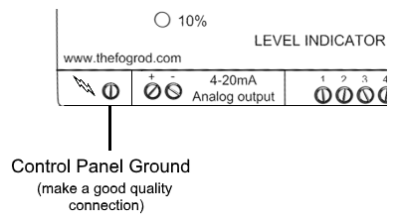
The surge protection on the FOGRod inputs divert excess current out of the LIT from this terminal.
Figure 6

FOGRod Connection
Wire the FOGRod cable to the LIT inputs (at the bottom of the LIT). These are color coded to identify the correct connection. If you get two wires mixed up you will not damage the system.

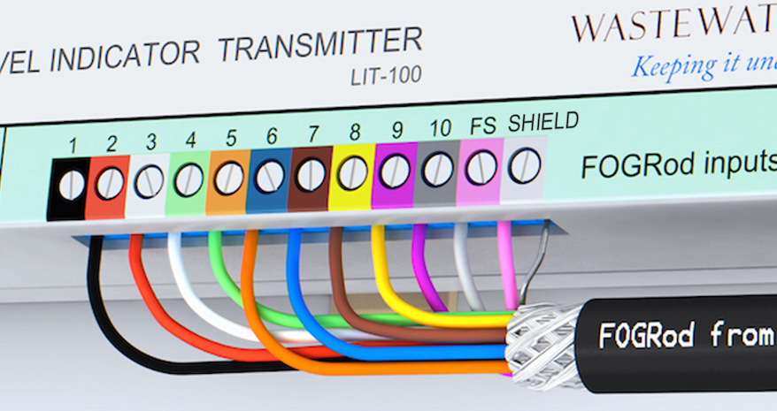
Figure 7

Ensure you have connected the drain wire (bare wire) to the SHIELD terminal - this is the screening to ensure noise from power cables does not interfere with the level signal.
Internally, the SHIELD terminal is connected to the FOGROD RETURN terminal, which should be connected to control panel ground.
If you connect the FOGRod cable through a junction box you must use shielded cable (e.g. spare FOGRod cable) to connect from the junction box to the LIT. And the shields of different cable segments should be connected.

3 ft FOGRod
The original 3ft FOGRod was a special version for very shallow wells, with 6 contacts, each separated by 6 inches. There is a new version of the 3ft FOGRod coming out in 2017 with 10 contacts, each separated by 3 inches. This new version is wired up exactly the same as the standard FOGRods.
For the 6-contact version - the wiring to the LIT uses inputs 5-10 along with FS (to detect cable problems) and the drain wire (to SHIELD).
Inputs 1-4 on the LIT should be jumpered together and to ground (you can connect them to SHIELD). This means that the LIT always registers at least 40% level, even when the well is empty. It also means that relays 1-4 are always closed.
Therefore, use the bottom contact on the FOGRod for Off and this corresponds to relay 5 which will be your Off relay (see figure 11).

Wiring Level Relays
Wire the appropriate level relays into your start/stop and alarm circuits. The level relays are all dry contact relays rated up to 240v, 5A resistive, and are isolated from each other (so different voltages can be used for different relays).
Alternatively, if your control system uses a 4-20mA signal because you have replaced an analog device (e.g. hydrostatic pressure transducer or ultrasonic), connect the Analog Output - see section: Analog Output
Example
If you have selected the 5th contact on the FOGRod as Lead Start (as shown in figure 2) then connect level relay 5 into the circuit that starts the lead pump.
In the example below the relay contacts correspond to the FOGRod levels shown in figure 2. So, if you are replacing 4 floats, just connect a pair of wires from each of the level relays (1, 5, 7, 10) into the same points into which your 4 floats were wired.
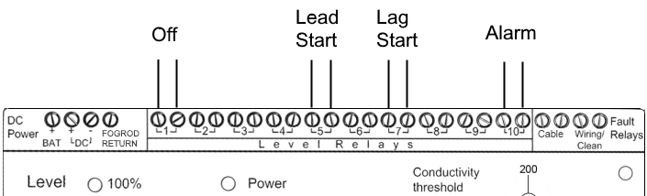
If you want to keep a float as an independent backup (this is a good idea), the simplest way is like this - pick your alarm relay (e.g. relay 10 in the example below) and wire this relay into the same terminals where the backup float is currently wired. Now either the FOGRod/LIT or the backup float will turn on the red light on your panel. Move the backup float in the wetwell so it is above the top of the FOGRod.
Figure 8

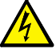
If the LIT relays are connected to 120v, ensure that suitably qualified personnel are carrying
out the installation.
Use 194°F (90°C) Rated Wire for all connections

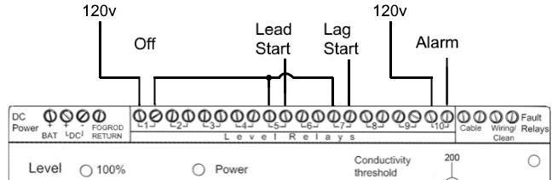
Figure 9 below is one way of wiring into a new panel. Alternatively you could have the Lead Start relay start the pump independently of the Off relay, but have the holding relay circuit broken by the Off relay.
Figure 9
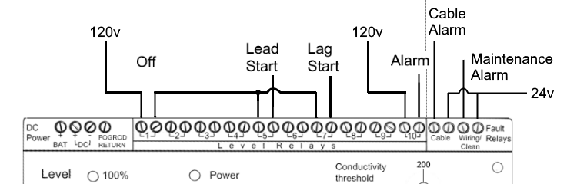
The relays are each independent electromechanical relays (like a switch), so you can apply different voltages to each relays. Here is the above example with 24v also used to connect the 2 fault relays into telemetry:
Figure 10 - Example with different voltage on fault relays

Wiring the Analog Output

The Analog Output does not need to be used to get the FOGRod and LIT working in your system. Reasons to use the Analog output:
- Replacing a 4-20mA level device - the control system used this 4-20mA value to alarm & start / stop pumps
- Provide a level signal to your telemetry system
See section Analog Output for the Analog Output wiring.

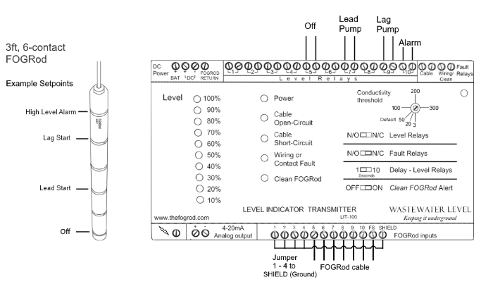
Example 6-contact, 3ft FOGRod Configuration
Figure 11

Basic Commissioning
- After wiring up the LIT, check the 4 DIP switches and the conductivity knob. See the next section (Understanding the LIT & FOGRod Functionality) for more details on these settings.
  - The Conductivity should be at Default unless there is a specific reason for a different setting.
  - Unless you are using level relays as Normally Closed, the Level Relays switch should be set to N/O, likewise for the Fault Relays switch.
  - The Delay - Level Relays switch can be set to 10 seconds if there is significant wave action in the well - the level has to be at or above a contact continuously for 10 seconds before the relay activates when this setting is selected. But remember during commissioning to expect this delay.
  - The Clean FOGRod DIP switch should be set to OFF (this is not critical - but when the FOGRod is lowered quickly into the well it will activate the Clean FOGRod alarm)
- Turn on or connect the DC power supply to the LIT.
- All the FOGRod LEDs will come on during start up, followed by two LEDs to indicate the software version number. Once startup is complete (a few seconds), the level indication on the front panel should match the level measured by the FOGRod. If not, see the Fault Conditions section below.
- As the level in the well increases, the level indication should correspondingly increase.
- When the lead pump start point is reached, the lead pump should start. If you manually disable this pump the level will keep rising and the lag pump level will be reached - then the lag pump should start.
- As the well is pumped down, when the off point is reached the pump should stop.
- If the inflow is too slow to allow this testing, then one possibility - depending on the well - is to unhook the cable from the S-hook and raise and lower the FOGRod in the water to simulate level change. If the well level is low it may be possible to lower the FOGRod to the base of the well and tilt it progressively over to get each contact into the water.
- Now basic commissioning of the LIT and FOGRod is complete.
Now move the Clean FOGRod alert DIP switch to ON - to detect rags and grease and minimise short-cycling when these occur

Fault Conditions during Commissioning
- If you see the Wiring or Contact Fault light this usually means that the wiring from the FOGRod to the LIT is not correct. One or more of the level LEDs will flash to show the problem area
  - Alternatively (very rare), it means there is a problem with the FOGRod or LIT.
  - You can check the LIT by connecting a jumper wire from the affected FOGRod input to SHIELD (internally connected to FOGROD RETURN) - this should stop the LED flashing - and if only one LED was flashing it will also turn off the fault LED.
  - You can check the FOGRod by doing a continuity test - first disconnect the FOGRod wires from the LIT, then connect an Ohm meter between the FOGRod wire and the related contact on the FOGRod. The resistance should be a few Ohms or less.
- If you see the Cable Open-Circuit fault light this usually means that the FS input or FOGRod input 10 are not wired up correctly.
- If you see the Clean FOGRod light this is not an alarm to be concerned about during commissioning. It usually means that the FOGRod was lowered into the wetwell at a speed that happened to trigger this alarm. Clear the alarm by moving the bottom DIP switch “Clean FOGRod Alert” to OFF and then back to ON.
- If no level is detected:
  - Check that the control panel ground is wired firmly into FOGROD RETURN at the top of the LIT - see earlier section Ground and Power Supply Connection - this is the most common reason for not detecting level
  - Turn the conductivity knob to the maximum setting (300). If level is now correctly indicated then your liquid has a low conductivity/high resistance. Move the conductivity knob counter-clockwise in small increments to find the point where the level LEDs turn off - the LIT needs to detect level for 1 second before activating level LEDs - so you need to take a little time. Once you find the point where the LIT detects level move the conductivity knob back clockwise by 1/8th of a turn and leave it there. However, municipal wastewater almost always works fine with the setting on Default, so please call us if you have any concerns about the installation setup. You may have a grounding issue.
  - Remember that if the Delay switch is on 10 seconds, you will not see any change in the LIT for 10 seconds
  - If none of these have solved the problem go to the Troubleshooting section
- If level LEDs are flickering erratically:
  - The conductivity knob should be moved to the Default setting - the most common reason for this fault condition (apart from a poor ground) is the conductivity knob being set to 300 (the most sensitive). In this setting, condensation on the FOGRod can cause a false reading.
  - For municipal wastewater, the Default setting is almost always the right setting.

Cleaning the FOGRod
This is very simple. The FOGRod is pulled up by its cable through the cleaning pad contained in the mounting bracket. This should clean off most, or all, of the grease. The FOGRod can also be pressure washed.
The important note here is that when the FOGRod is lowered back into the wetwell, multiple contacts going wet together will activate the Clean FOGRod alarm.
Simply flick the Clean FOGRod DIP switch to OFF and back to ON to clear it. (Alternatively, cycling power to the LIT will have the same effect).
In v.1.7 software onwards (as explained elsewhere in this manual), when multiple contacts go wet together only the first new level LED and level relay will turn on at the start - and the Clean FOGRod alarm LED will start flashing. After about 3 minutes the relays for the other affected contacts will turn on. This is designed to prevent short cycling when too much grease - or rags - short out adjacent contacts.
So it is important to ensure the DIP switch goes back to ON before staff leave the station.

Understanding the LIT & FOGRod Functionality
The LIT:
- identifies four fault conditions, which activate four LEDs on the front panel and two fault relays
- has five configuration settings, via four DIP switches and one conductivity setting
- has one analog output
  - starts at 4mA for zero level and increases by 1mA for each contact covered (so is 14mA maximum)
  - reads 0mA for zero level when a cable fault is also identified

Understanding Operator Panel Alarms and Fault Relays
Fault LED | Relay | Fault Condition
Cable Open-Circuit | Cable | Loss of FOGRod cable. Specifically, continuity between FS and FOGRod input 10. Possible if cable broken, e.g. eaten by rats. In earlier versions, electrical noise could induce a false alarm.
Cable Short-Circuit | Cable | Short between FS and FOGRod input 10. Possible if wiring insulation stripped in conduit.
Wiring or Contact Fault | Wiring/Clean | A FOGRod contact is registering as wet above a contact that is dry. It could be:  - a wiring fault  - a problem with a specific FOGRod contact due to bad grease buildup (insulating the contact)  - a rag shorting out alternate contacts (because the offset of each contact by 120 degrees means a rag is less likely to short out adjacent contacts)
Clean FOGRod | Wiring/Clean | The FOGRod needs cleaning - the build-up of fats, oils and greases is starting to affect the level readings by the LIT.  This fault is activated when multiple contacts are detected as going wet together. It is most commonly activated due to large grease ring over the lead start point and contacts below.  It is also activated by lowering the FOGRod quickly into the wet well (just move the DIP switch to OFF and then ON)

See the Troubleshooting section if you have any of these alarms and can’t work out why.
Note, prior to 2015 the Cable fault was written as Failsafe on the LIT.
The Wiring or Contact Fault clears when the level drops below the contacts affected.
The Clean FOGRod alarm latches on (this is new in v1.6 onwards), and stays on until the DIP switch is moved to OFF (and then the DIP switch should be moved back to ON), or power is cycled. The LEDs corresponding to the FOGRod contacts that caused this problem will continue to flash until the fault is cleared with the DIP switch.

Clean FOGRod Alarm
The functionality changed a lot in v1.7. It is simple to understand, but does operate differently. It uses the patented technology developed by Wastewater Level.
When multiple contacts go wet together (within 5 seconds) a 3-minute timer starts and the Clean FOGRod LED starts flashing. Only the first new level relay and LED turn on at this stage. At the end of the timer period if any of the other contacts that went wet are still wet the Clean FOGRod LED goes solidly on (it stops flashing) and the fault relay latches on. The new level is the highest wet contact - so all of the level relays up to the highest wet contact are activated.
If, during the timer period, a higher level is detected (higher than any of the contacts that all went wet together) then the fault relay latches on, and all the level relays up to the new highest level will go on.
This means that ragging and grease problems, even in the extreme, will limit the starts in a two-pump station to 10 starts per pump per hour.

Example:
Let’s say contact 1 is the Off point, and contact 5 is Lead Start (as with figure 2 and figure 7).
Suppose grease buildup has reached such a bad state that enough liquid is held inside the grease and shorts contact 1 all the way up to contact 5. When the level reaches contact 1 it shorts to 2, 3, 4 and 5. The LIT detects 1, 2, 3, 4 and 5 going wet together. Clearly, the level is really only at contact 1 at this time.
In v1.5 the LIT activated a fault relay and the Clean FOGRod LED. It flashed LEDs 10%-50% to indicate the problem area. It also turned on relays 1-5.
In v1.7, relay 1 will activate and LED Level 10% will go on. But relays 2-5 will NOT activate straight away - avoiding short-cycling. An internal 3-minute timer starts and the Clean FOGRod alarm LED starts flashing.
At the end of the timer period, if contacts 2-5 are still “wet” then relays 2-5 will NOW activate and the Clean FOGRod alarm will latch on (the fault LED lights up and the fault relay activates). Level LEDs 10%-50% will flash to show the problem area on the FOGRod. In this example, the lead pump will be started - but 3 minutes later.
If during the timer period, contact 6 goes wet this is clearly a real level and so the LIT activates relays 2-6 (relay 1 is already active). It also latches on the Clean FOGRod alarm LED & relay and flashes the affected level LEDs.
The level LEDs that were affected by this fault condition will flash - and continue doing so until the Clean FOGRod DIP switch is moved to OFF.
If during the timer period these contacts go dry then the Clean FOGRod alarm stops flashing and the internal timer stops. This eliminates any alarms due to temporary ragging.
The end result of this additional logic is that even with bad grease or ragging problems being ignored for a long time, there will be a maximum of 10 starts per hour per pump during peak periods. Short cycling has been minimized.
The FOGRod & LIT will always detect a positive OFF signal because once the level drops below the bottom of the rod it is impossible to get a false ON reading (a false ON reading would need the 5v signal to jump through fresh air to the receding water level below). The additional contacts above the Lead Start will always ensure that the pump starts. And now this v1.7 feature minimizes any problems of short cycling due to rags and grease.

Configuration Settings
DIP 1 - N/O or N/C Level Relays
The default setting is for relays to be open when the FOGRod contact corresponding to that relay is not covered with liquid.
This can be changed by moving the switch to the N/C position.
Example: Level is at 40%
  - With DIP switch 1 at N/O (default) - LEDs 10%-40% are lit and relay contacts 1-4 are closed, relay contacts 5-10 are open
  - With DIP switch 1 at N/C - LEDs 10%-40% are lit and relay contacts 1-4 are open, relay contacts 5-10 are closed
DIP 2 - N/O or N/C Alarm Relays
The default setting is for the alarm relay contacts to be open when the alarm conditions are not present.
This can be changed by moving the switch to the N/C position.
This N/C condition is often preferred as a failsafe mechanism. Under a “no fault” condition both fault relays (relays 11 & 12) would be closed and telemetry could be configured for that.
Therefore, if power is lost to the LIT, both fault relays will go open - indicating loss of power, or loss of the LIT.
DIP 3 - Delay on Level Relays
The default setting is for 1 second from liquid covering the metal contact on the FOGRod to the level relay activating.
This can be changed by moving the switch to the 10 second position. Then the level relay will activate only when a contact has been covered continuously for 10 seconds. Likewise, the level relay will only deactivate when a contact has been dry continuously for 10 seconds.
This setting is useful when there is a lot of wave action in the well. It is also useful if the FOGRod can swing into the rails or chains in the well.
DIP 4 - Clean FOGRod Alert
The default setting is ON. This means that when the LIT detects that the FOGRod needs cleaning the alarm light will activate and relay 12 will activate. An active alarm can be cleared by moving the switch to the OFF position (and then back to ON to reactivate the detection).
Note: it is usual for the alarm to be activated by lowering the FOGRod quickly into the liquid (as explained earlier), and it is possible for the alarm to be activated by temporary ragging. If the FOGRod is clean and the alarm is on, simply clear the alarm with the DIP switch.

Conductivity Threshold
The setting for conductivity has a default of 50. This means that if the resistance through the wastewater and the ground return path is greater than this value the LIT will indicate “dry”. And if the resistance measured is less the LIT will indicate “wet”.
In most wastewater lift stations this setting should not be changed from the default.
For collection systems with large inflow in mountain areas the wastewater might be a low conductivity and then the threshold should be increased to a higher value like 150.
For discussion about changing the conductivity threshold please call technical support at Wastewater Level.

Analog Output
The analog output provides a 4-20mA signal to represent level measured by the FOGRod:
Level | Analog Output, mA
0% | 4.0
10% | 5.0
20% | 6.0
30% | 7.0
40% | 8.0
50% | 9.0
60% | 10.0
70% | 11.0
80% | 12.0
90% | 13.0
100% | 14.0

When the level = 0 AND the cable alarm condition is true, the analog output will measure 0 mA.

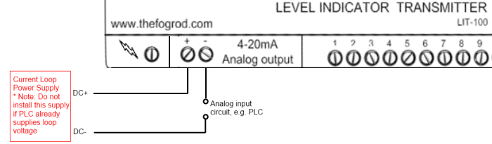
Wiring the Analog Output
Figure 12

The analog output circuit can be powered by the same power supply used to power the LIT, but be careful of ground loops. Ensure that the power supply negative (DC-) is not tied to earth ground.
Remember that if you are testing this with a DVM prior to connecting to a PLC analog input, you must include a resistive load in series otherwise you are putting the analog output into a short circuit condition.
The maximum load, RL(max) = (Vsupply - 7) / 0.014.
So for 12v, RL(max) = 357 Ohms. For 24v, RL(max) = 1,200 Ohms.

Hazardous Location Installation

Class I Division 2
The FOGRod is suitable for use in Class I Division 2 Group D when connected to the LIT in an unclassified area (UL file number E467390).
Combinations of equipment in your system are subject to investigation by the local Authority Having Jurisdiction at the time of installation.
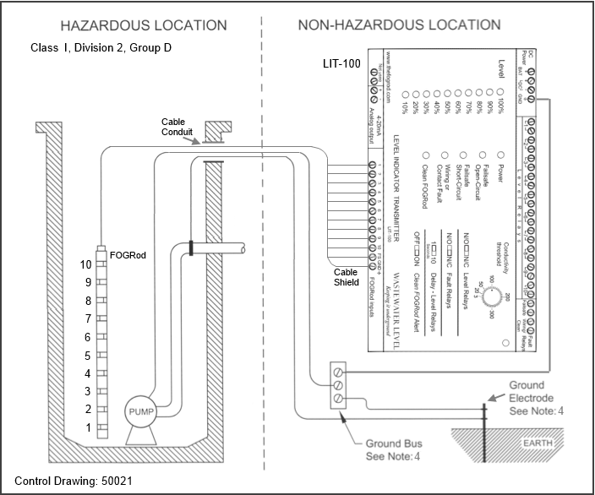
Control Drawing 50021:
Notes:

- Installation shall be done in accordance with the National Electric Code (or relevant code for your location eg. ATEX for Europe). This is the responsibility of the INSTALLER
- Maximum distance between the FOGRod and LIT shall be 150 feet. Cable capacitance is calculated as 60 pF/ft = 9 nF maximum; cable inductance as 0.2 uH/ft = 30 uH maximum
- No other devices in the hazardous area shall be connected to the LIT
- The hazardous location ground and the LIT ground must be connected to the ground bus in the panel
WARNING - EXPLOSION HAZARD - Do not replace FOGRod or cable unless power has been switched off or the area is known to be non-hazardous

Class I Division 1
The FOGRod is suitable for use in Class I Division 1 locations when connected to the LIT in an unclassified area through an approved intrinsically safe barrier. Examples are 2-channel barriers: R Stahl 9002/77-220-146-001 and P&F Z967. Wastewater Level has tested these barriers with the FOGRod and LIT.
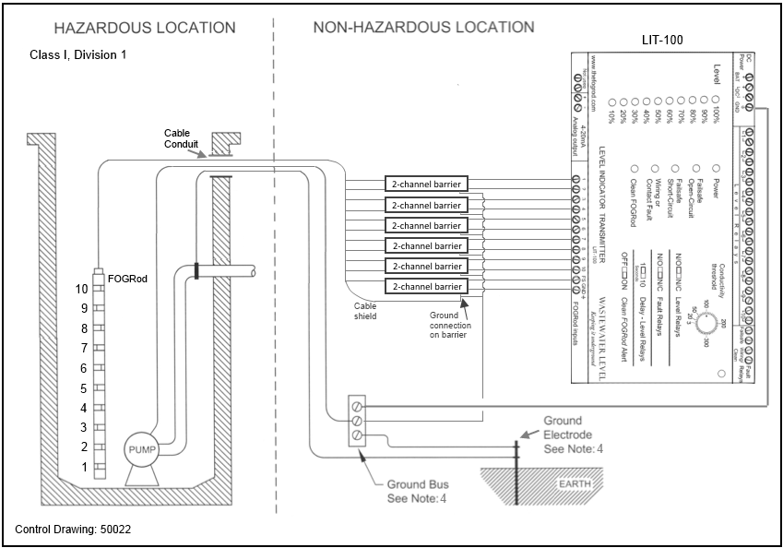
Control Drawing 50022:

- Installation shall be done in accordance with the National Electric Code (or relevant code for your location eg. ATEX for Europe)
- Maximum distance between the FOGRod and LIT shall be 150 feet. Cable capacitance is calculated as 60 pF/ft = 9 pF maximum; cable inductance as 0.2 uH/ft = 30 uH maximum
- The hazardous location ground and the LIT ground must be connected to the ground bus in the panel
- The FOGRod is a “simple apparatus” under NEC 504.2 and therefore does not need a UL listing as stated in NEC 504.4
WARNING - EXPLOSION HAZARD - Do not replace FOGRod or cable unless power has been switched off or the area is known to be non-hazardous

Wiring the R Stahl 9002/77-220-146-001 barriers for Class I Division 1

The R Stahl unit is a dual-channel a.c. barrier, dimensions 0.5” x 4.1” x 2.8” (12mm x 103mm x 72mm). A typical installation requires 6 of these barriers.
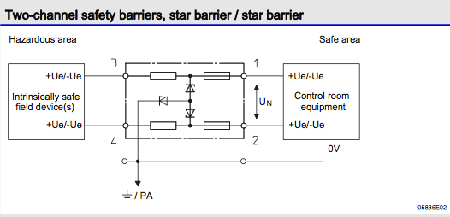
Wiring it between the FOGRod and the LIT is very simple. Here is the schematic of the barrier from their datasheet:
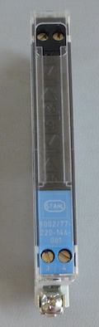
Here is the front view (below). Terminals 1 & 2 at the top are the two channels that connect to the LIT (safe area), and terminals 3 & 4 at the bottom are the two channels that connect to the FOGRod (hazardous area):

1st barrier - LIT inputs 1 & 2:
Connect FOGRod black (1) to terminal 3, Connect red (2) to terminal 4
Connect LIT "FOGRod input 1" to terminal 1, Connect "input 2" to terminal 2
2nd barrier - LIT inputs 3 & 4:
Connect FOGRod white (3) to terminal 3, Connect green (4) to terminal 4
Connect LIT “FOGRod input 3” to terminal 1, Connect “input 4” to terminal 2
and so on for the 3rd, 4th and 5th barriers.
For the 6th barrier - LIT inputs FS & SHIELD:
Connect FOGRod pink (FS) to terminal 3, Connect drain wire (shield) to terminal 4
Connect LIT “FOGRod input FS” to terminal 1, Connect LIT "SHIELD" to terminal 2
And for all barriers, connect up the Ground connection point to control panel ground.

Wiring the Z967 barriers for Class I Division 1

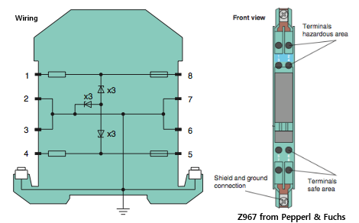
The Z967 is a dual-channel barrier, dimensions 0.5” x 4.5” x 4.3” (12.5mm x 115mm x 110mm):
1st barrier - LIT inputs 1 & 2
Connect FOGRod black (1) to terminal 1, Connect red (2) to terminal 4
Connect LIT "FOGRod input 1" to terminal 8, Connect "input 2" to terminal 5
2nd barrier - LIT inputs 3 & 4
Connect FOGRod white (3) to terminal 1, Connect green (4) to terminal 4
Connect LIT FOGRod input 3 to terminal 8, Connect input 4 to terminal 5
3rd barrier - LIT inputs 5 & 6
Connect FOGRod orange (5) to terminal 1, Connect blue (6) to terminal 4
Connect LIT FOGRod input 5 to terminal 8, Connect input 6 to terminal 5
4th barrier - LIT inputs 7 & 8
Connect FOGRod brown (7) to terminal 1, Connect yellow (8) to terminal 4
Connect LIT FOGRod input 7 to terminal 8, Connect input 8 to terminal 5
5th barrier - LIT inputs 9 & 10
Connect FOGRod purple (9) to terminal 1, Connect gray (10) to terminal 4
Connect LIT FOGRod input 9 to terminal 8, Connect input 10 to terminal 5
6th barrier - LIT inputs FS & SHIELD
Connect FOGRod pink (FS) to terminal 1, Connect drain wire (shield) to terminal 2
Connect LIT FOGRod input FS to terminal 8, Connect LIT "SHIELD" to terminal 7
And for all barriers, connect up the "Shield and Ground connection" point to control panel ground.

Troubleshooting

No Level Signal
Zero Level Indication on the front panel when liquid is covering at least one FOGRod contact

Brief summary: If the power LED is on then the LIT is working. The control panel ground must be connected to FOGROD RETURN at the top of the LIT. This is essential to complete the circuit. If you are working with a tank that is insulated from control panel ground (e.g. a plastic chemical tank) then you will need to use a ground rod in the liquid connected to control panel ground.
You can test a LIT input (e.g. input 1) by connecting a jumper wire from input 1 to SHIELD. If the 10% light comes on, that LIT input is working. If it doesn’t, the LIT inputs have failed (very rare) so call us. You might have a grounding issue - so turn all the pumps off. Do you see the correct level reading now? If you are working with municipal wastewater the default conductivity setting should work fine - is the setting on the default? If you are working with more resistive liquid try turning the knob clockwise (more sensitive) - does the LIT register the correct level now?
Detailed fault-finding:
- Check the Power LED - is it on?
  - If yes, go to 3.
  - If no, there is no supply to the LIT, insufficient supply, or the LIT has failed. Go to 2.
- Disconnect the LIT from your power supply, measure the voltage output from the power supply and write it down.
  - If the dc voltage is not between 10 - 30v then you must replace the power supply. [End]
  - If the dc voltage is between 10 - 30v then either there is a problem with the LIT or the supply is not able to deliver enough power.
  - The dc voltage when disconnected from the LIT is between 10-30v. Now connect up the LIT, measure the dc voltage across the LIT input and write it down. If it is less than 10v the power supply does not have enough power available. Is it powering other devices as well? We recommend replacing the power supply. [End]
  - The power supply is still delivering 10-30v when connected to the LIT but the LIT Power LED is not on. The LIT has failed. Please call us to arrange a replacement. We need your old unit back to do a root cause analysis of the failure. [End]
- The Power LED is on, so the LIT is operating. Is the FOGROD RETURN terminal at the top of the LIT connected to the control panel ground?
  - if yes, go to 4.
  - if no, make a good quality connection from control panel ground to FOGROD RETURN - you will probably see the level LEDs come on.
- The Power LED is on, and ground is connected to FOGROD RETURN. Ensure the Delay DIP switch is set to 1s so all the subsequent tests react quickly. Check the conductivity knob. Write down the value it is set to. Then turn the knob clockwise to 300. Do any level LEDs come on?
  - If yes, it appears the FOGRod and LIT are working ok. You might be working with a less conductive liquid, or you might have a grounding problem.
  - In municipal wastewater, we have found that the default value always works fine - it’s possible that liquid conductivity is low (high resistance liquid) but we suspect a grounding issue. In a couple of cases we have seen, when a pump runs, the conductivity threshold changes. That is, with the pumps off, a lower setting works ok, but when a pump turns on a higher setting is needed to indicate level. With all pumps off, slowly turn the conductivity knob back to the point where all of the covered contacts are indicated on the display. Write down the value. Increase the conductivity (clockwise) about 1/8th of a turn so the setting is not on the “just working” threshold. Please call us on (406) 545 3023 to discuss - we want to make sure your station is working ok. [End].
  - If no, go to item 5.
- It’s easy to test the LIT inputs - we just connect them to ground. Take a jumper wire with stripped ends and insert one end into FOGRod input 1 and the other end into the SHIELD input to the right. Note: you need to push the wire into the terminal receptacles and tighten the screw, not just touch the wire to the top of the screw (the resistance can be very high just touching the screw top).
  - Does the Level 10% LED come on?
  - Do the same for FOGRod input 5. Does the Level 50% LED come on? (10% - 40% will be flashing to indicate that inputs 1-4 are “dry” while input 5 is “wet”, and the Wiring or Contact Fault LED will come on, but you just ignore that).
  - If the above two tests were successful then the level LEDs are working, and the conductivity circuitry is functional. Go to 6.
  - If the above two tests were both unsuccessful, then there is a problem with the LIT and we need to replace it. Please call us. [End].
- The LIT is powered up, shorting some inputs to ground was detected and control panel ground is connected to FOGROD RETURN on the LIT. Now we need to check the electrical connection from the FOGRod contacts to the end of the cable. Pull the FOGRod out of the wet well. Visually inspect the contacts. Wipe them clean, or hose them down. Ensure that you can see clean metal contacts. Replace the FOGRod into the wetwell. Is there a level reading on the display?
  - if yes, the problem is solved. The FOGRod contacts were dirty. Please review the location of the FOGRod, is it hanging near the inflow in the turbulent part of the well? Please call us - we will be happy to discuss the situation and make any recommendations
  - if no, go to 7
- The LIT is powered up, shorting some inputs to ground was detected, control panel ground is connected to FOGROD RETURN on the LIT and the FOGRod contacts are visibly clean. Position the FOGRod so you can use a DVM to check the resistance from contact 1 on the FOGRod to wire 1 from the FOGRod (currently wired into the LIT). If they are too far apart you will need a length of wire. Set the DVM to resistance on a scale that will measure 10 Ohms. Disconnect FOGRod input 1 (black wire) from the LIT and clip the DVM onto the bare wire. Connect the other DVM input to the first metal contact (closest to the bottom of the FOGRod). Write down the resistance reading. You must have the wire disconnected from the LIT. Is the resistance value less than 5 Ohms?
  - If no, there may be an internal problem in the FOGRod. We’ve never seen it so far, but it could happen. Please call us. [End]
  - If yes, go to 8.
- The connection between the liquid and control panel ground might be a problem. There are two easy ways to check this:
  - (Easiest but only a temporary solution) We will use the bottom FOGRod contact as the ground. First, remove the control panel ground wire from FOGROD RETURN at the top of the LIT. Next, remove the black wire from input 1 at the bottom of the LIT and wire it into FOGROD RETURN. You won’t see a level signal from the first contact because you are now using it as the ground, but when the level reaches contact 2 or above you should see level registering on the bargraph (you will also see “Wiring or Contact Fault” and the 10% level LED flashing but ignore this - it is just telling you input 1 is not connected). If you are now getting a level reading it demonstrates there is a problem with the ground connection, and move to the next test.
  - Now if you can, use a ground rod (i.e., a solid heavy piece of metal) and connect firmly to a long wire. Put the ground rod into the wetwell and connect the other end of the connected wire to FOGROD RETURN at the top of the LIT. If you had tried the previous test and connected the black FOGRod wire into FOGROD RETURN be sure to replace it in input 1. Does the LIT read the level correctly? If so, you now have a workable long term solution to your ground problem. Of course, solving the ground problem is preferable but this solution will also be fine.
  - If the two tests above didn’t solve the problem please call Wastewater Level and together we will try and work out what has been missed. [End].

Level Signal when Wetwell is Empty
The level is below the bottom of the FOGRod but you are still reading a level on the LIT

Brief summary: Most likely, some inputs have been damaged by lightning and failed short circuit. This is very easy to verify and usually easy to work around while you wait for a replacement LIT.
The only other two explanations are i) the level is not actually off the bottom of the rod (perhaps it is below the bottom contact), condensation is running down the rod and the sensitivity is very high (conductivity knob turned clockwise to the maximum); ii) the FOGRod contacts are resting against something like a chain or ladder, or against a wet concrete wall.
Detailed fault-finding:
- You have the level below the bottom of the FOGRod but one or more level LEDs are still on. You might also see some level LEDs flashing, and if you do, you will see the Wiring or Contact Fault alarm LED on. These flashing level LEDs are not important, the LIT is just telling you that it measures some contacts “dry” below contacts that appear to be “wet”. For example, if input 3 has been damaged short circuit but inputs 1 and 2 are ok and the FOGRod is out of the water then the LIT will see input 3 as wet and inputs 1 & 2 as dry.
  - Using a small screwdriver, unscrew the input(s) that are solidly on - for example, if 30% is on, unscrew input 3 - and remove the wire(s). Do this for all of inputs corresponding to the solidly on LEDs.
  - Do the level LEDs stay on?
  - If yes, go to 2
  - If they go out then the LIT is fine and your problem was something different but easy to work out, go to 3
- The LIT inputs have been damaged by lightning. Each input protection device fails short circuit if it cannot deal with the amount of energy. (These protection devices are like fuses except they fail short circuit). We will need to replace your LIT, but in the meantime you can almost always get your station up and running using the existing LIT.
  - It is easiest to explain using a concrete example - say input 3 has been damaged:
  - Move the wires from relay 1 to relay 4 - this now uses relay 4 to turn off your pump. (If you are using relay 4 or below to start your lead pump you need to also move these wires to a higher relay).
  - Disconnect the black FOGRod wire from input 1 and connect it into input 4 (remove the green wire from input 4 when you do this).
  - The general case - note the highest LED which is permanently on, use the relay for the LED above that to turn off your pumps, and wire the black wire (contact 1 on the FOGRod) into that input. So if 10% LED only is on, use relay 2 for off, and wire the black wire into input 2.
  - The last point, not essential, if you have say 30% on and 10% and 20% flashing and you want to stop the flashing LEDs (and Wiring or Contact Fault alarm LED), just connect a jumper wire from input 3 to input 2 and input 1. This will make the other inputs appear wet and the LIT will stop flashing those levels.
  - Then call us so we can arrange for a replacement LIT. [End].
- We’ve verified that the LIT inputs go out when they are not connected so the only conclusion is that either the FOGRod contacts are touching something that electrically connects to ground, or there are some loose wires touching the LIT inputs (otherwise it is like a lightbulb staying on when you have turned off the switch).
  - check the inputs to the LIT - make sure you can see there are no loose wires
  - pull the FOGRod out of the wetwell, but don’t lie it on the ground, instead rest it at an angle against something so no FOGRod contacts are touching anything. If this makes the level LEDs go out, return the FOGRod to the wetwell and ensure it is not resting against anything like a chain.
  - Do these tests fix the problem? If not, please call us and together we will work out what has been missed.

Cable Open Circuit
Brief summary: The Cable Open-Circuit alarm is designed to detect broken FOGRod cable - of course this is extremely rare. So far as we know it has not yet ever happened. Note that this alarm does not affect the operation of the LIT, it only turns on the alarm light and activates the Cable fault relay. Level indication, level relay operation and analog output all function exactly as normal.
The alarm will come on if either the FOGRod gray wire is not connected to input 10, or the pink wire is not connected to input FS. It is possible that you have switched red and pink - with some FOGRods the red/pink wiring color is too similar, especially in low light.
This alarm has also been triggered occasionally by electrical noise in the panel. The noise thresholds were changed in v1.8 onwards to prevent this. If you are reading this manual but have an older LIT it may be noise (from VFDs, from being located next to a transformer).
The alarm takes 10 seconds to activate when the LIT detects the condition, but goes out immediately when the cable appears to have the right resistance.
Detailed fault-finding:
- Check wiring: check the gray wire is connected to input 10 and pink to FS. If the level reading is 30% or higher and the 20% level LED is not flashing then you have definitely connected red into input 2. If the level is 10% or 0% then you might have connected red into pink and pink into red. Swap them around - does the fault go out?
- Check the FOGRod resistance. You will need a resistance meter that can measure around 60kOhms. Disconnect the gray and pink wires from the LIT and connect your meter to these wires (not to the LIT). You should measure about 62kOhms. If you don’t, write down the value and call us - it seems like something has happened to the FOGRod.
- If you have tried the first two tests, it could be electrical noise. Do you have v1.8 onwards? If you are not sure, cycle power to the LIT and you will see all the LEDs come on, followed by two level LEDs in turn - and then the unit goes to normal operation. The two level LEDs give you the version number. For example, if you see 10% then 70%, the unit has v1.7 software. If the software version is v1.7 or earlier then the alarm is most likely caused by noise in the panel. Call us and we can work out a replacement unit. If the LIT is still reading level the situation is not urgent - the LIT & FOGRod will continue to measure level despite this alarm.

Cable Short Circuit
Brief summary: The Cable Short-Circuit alarm is designed to detect stripped insulation in the FOGRod cable - of course this is extremely rare. So far as we know it has not yet ever happened. Note that this alarm does not affect the operation of the LIT.
This alarm will come on if there is a short (or low resistance path) between input 10 and FS. The alarm takes 10 seconds to activate when the LIT detects the condition, but goes out immediately when the cable appears to have the right resistance.
Detailed fault-finding:
- Check wiring: check the gray wire is connected to input 10 and pink to FS and no loose wires are bridging these terminals.
- Check the FOGRod resistance. You will need a resistance meter that can measure around 60kOhms. Disconnect the gray and pink wires from the LIT and connect your meter to these wires. You should measure about 62kOhms. If you don’t, write down the value and call us - it seems like something has happened to the FOGRod.
- If you have tried the first two tests and haven’t fixed it, please call us and we together we will try and figure it out.

Wiring/Contact Fault alarm
Brief summary: The wiring/contact fault is activated when a contact is registered as wet above a contact that appears to be dry.
This could be due to faulty wiring, grease buildup on the FOGRod, or a damaged input from lightning.
The LEDs corresponding to the contacts that appear “dry” will flash. This alarm clears when the level drops below the affected area - that is, the alarm does not latch.
Detailed fault-finding:
- First of all, confirm the level on the FOGRod and see if it matches the level display.
  - If the real wetwell level matches the reading on the LIT, then the flashing LED indicates a “dry contact” that we expect to be wet. If the LIT indicates a wetwell level much higher than the actual level then the problem is a false wet signal (a damaged input or the FOGRod resting against a chain or ladder).
  - If the LIT level matches the real level go to 2.
  - If the LIT level is higher than the real level go to 6.
- Pull the FOGRod up through the wiper in the mounting bracket. Check the contact corresponding to the LEDs that were flashing - is it clean now? Lower the FOGRod back into the wetwell - this might trigger the Clean FOGRod alarm - just clear the alarm by moving the Clean FOGRod Alert DIP switch to off and then back to on.
  - Is the same level LED still flashing? If no, the Wiring or Contact Fault will also be cleared and the problem is solved.
  - If yes, go to 3.
- Check the FOGRod wires match the color coding on the terminals, and all the wires are firmly in their terminal receptacles. The input to check corresponds to the flashing LED. If the wiring all seems correct..
  - Connect a jumper wire from the input corresponding to the flashing LED to SHIELD. The flashing LED should turn on solidly (stop flashing). For example, if the 30% LED is flashing, connect a jumper wire from input 3 to SHIELD (you should push the wire into the terminal receptacle and tighten the screw, not just touch the wire to the top of the screw).
  - Does the LED turn on solidly? If no, the LIT has a fault - call us.
  - If yes, go to 4.
- What is the conductivity setting? If your application is municipal wastewater it should be on default. But just to check that there are no issues with it being on the threshold - move the setting clockwise to 300. Does the flashing LED turn on solidly and the alarm turn off?
  - If yes, the problem is kind of solved, but there might be a ground problem at site. To avoid the system being too sensitive, turn the conductivity setting slowly back towards default until the level LED starts to flash again and now turn it clockwise about 1/8 of a turn. Please call us, we want to be sure your site is working ok.
- So the FOGRod is clean, the wiring has been checked, the LIT input has been checked, the sensitivity has been turned to the maximum, but there is still no current flowing into that input. Now we need to check the FOGRod. Pull the FOGRod out of the well. Disconnect the wire corresponding to the flashing level LED - for example, if 30% is flashing, you need to disconnect input 3 (white). Using an Ohmmeter, clip one end of the meter to the FOGRod wire you have disconnected, and touch the other end to the metal FOGRod contact in question. In the example where we are checking input 3 you need to count up from the bottom of the rod to the 3rd contact. What is the resistance? It should be a few Ohms (typically it is 1-2 Ohms).
  - If it is a few Ohms or less then something is not making sense. This is just like checking why a lightbulb doesn’t come on and we’ve eliminated everything. Please call us and together we will work it out. [End]
- The LIT level is higher than the real level. There are two possibilities - either an input is damaged by lightning and has gone short-circuit, or the FOGRod is touching a ladder or chain. Both of these are easy to check and it doesn’t matter which one you do first.
  - Look down in the wetwell - is the FOGRod touching anything? If you aren’t 100% sure, pull the FOGRod up out of the wetwell and look again at the LIT - is the level reading zero? If not, there must a problem with an LIT input. If the level is reading zero the LIT is fine and there was a problem with the FOGRod location. Lower it back into the wetwell and hang back from the mounting bracket (lowering the FOGRod into the liquid can set off the Clean FOGRod alarm - just clear it by moving the Clean FOGRod Alert DIP switch to off and back to on). Is the LIT again reading the false higher level? If so, there must be something conductive touching the FOGRod. Feel free to give us a call so we can assist.
  - Disconnect the FOGRod wire from the input corresponding to the level LED that was on solidly. For example, if the 70% level LED was on (and 10%-60% flashing) then disconnect input 7 from the LIT. Does the 70% level LED stay on? If yes, the LIT is damaged, possibly by lightning. Take a look at the earlier section “Level Signal when Wetwell is Empty” - it explains how to keep the station operating until a replacement LIT arrives. Please call us so we can arrange a replacement LIT.
  - If neither of these tests has worked out, please call us so we can help you solve the problem.

Clean FOGRod alarm
This alarm is triggered by very rapid level changes. Usually it indicates that there is a significant build up of grease on the FOGRod, or rags bridging multiple FOGRod contacts, so that the rod needs cleaning.
This alarm also activates when the FOGRod is lowered quickly back into the well. So you should always expect to clear the alarm after returning the FOGRod back into the well.
The buildup or rags should correspond to the location of the flashing level LEDs on the LIT. If you visit the site and see the alarm but the rod looks clean it might have been caused by a temporary rag.
To reset the alarm condition, move the ‘Clean FOGRod Alert’ DIP switch to the OFF position, then move it back to the ON position.
If - after the rod is clean and back in the well, and after clearing the alarm, the alarm activates again, please call us. We want to help you understand what is going on.

Specification

LIT-100

Environmental
Power | 10v-30v d.c., max 4W (power supply should provide more than 4W)
Temperature rating, Operating | -40 °F to 158 °F (-40 °C to +70 °C)
Temperature rating, Storage | -40 °F to 185 °F (-40 °C to +85 °C)
Maximum relative humidity | 95%
Maximum altitude | 6,560 ft, 2000 meters
Environment | Indoor use, Pollution Degree 2 and Overvoltage Category 2
Approvals | UL | C-UL (CSA) | CE | RCM (Australia)
Dimensions | 7" (W) x 4" (H) x 1.5" (D)  178mm (W) x 102mm (H) x 38mm (D)
Enclosure type | High impact ABS with DIN rail clip

I/O and Indication
Relay Outputs - Level | 10 relays, rated at 240VAC / 30VDC 6A (resistive load), configurable as normally open or normally closed (N/O or N/C)
Relay Outputs - Faults | 2 relays, rated at 240VAC / 30VDC 6A (resistive load), configurable as normally open or normally closed (N/O or N/C)  - 1 relay for cable open circuit or short circuit (cable problem)  - 1 relay for contact dry below wet or FOG (fats, oils, grease) buildup
LEDs – Level | 10 green LEDs
LEDs – Fault & Power | 1 green LED for power  4 red LEDs for faults — Cable open circuit; Cable short circuit; Wiring or Contact; Clean FOGRod
Analog Output | Level 4-20mA output, 4mA = zero level, 5mA = 10%, 6mA = 20%, etc. to 14mA = 100%  Accuracy better than 1%  Max load depends on supply voltage: 330 Ohms with 12v supply, > 1 kOhms with 24v
FOGRod I/O | 11 FOGRod I/O - 8 VAC, low frequency: 10 level, 1 failsafe (plus drain wire for shield)
Terminals | All terminals standard screw type.  Wire Size: 22awg -14awg (0.7 - 1.6mm diameter)  Wire Rating: 194°F | 90°C minimum rating  Wire type: Stranded or Solid  Torque: Maximum 2.6 lb-in (0.3 Nm)

Setting
Conductivity | Default conductivity threshold = 50kOhms, range from 3k – 300kΩ
DIP switches | 1. Level relays: Normally Open / Normally Closed  2. Fault relays: Normally Open / Normally Closed  3. Level relays and LEDs: 1 sec / 10 sec activation  4. Clean FOGRod alert: On/Off

FOGRod

Setting
Construction | PVC
Metal contacts | AL6XN (super-austenitic steel for very high corrosion resistance)
Dimensions | Diameter: 1⅜ in (35mm)  FOG-5: Length 5ft (1525mm), Separation between contacts 6 in (152mm)  FOG-7.5: Length 7ft 3in (2217mm), Separation between contacts 9 in (229mm)  FOG-3: Length 3ft (917mm), 6 contacts, Separation between contacts 6 in (152mm)  New version, length 34 in (863mm), 10 contacts, separation between  contacts 3 in (76mm)
Weight | FOG-5: 5.5 lbs (2.5kg), excluding cable  FOG-7.5: 7.7 lbs (3.5kg), excluding cable  FOG-3: 3 lbs (1.5kg), excluding cable
Rating | Nema 6P | IP68
Temperature rating | Operating: -40 °F to 158 °F (-40 °C to +70 °C)  Storage: -40 °F to 185 °F (-40 °C to +85 °C)
Cable | Custom 11-core cable with braided shield, conductor size 20 AWG or greater  PVC insulation & outer jacket
Mounting bracket | Aluminum (powder coated) with polyurethane cleaning pad

Specifications subject to change without notice

